5CS022 Distribute and Cloud Systems Programming Week 1 Workshop
Overview

The aim of this workshop is to familiarise you with building, compiling and running MPI programs. You can carry out this workshop on your own Linux system

Tasks

- Download the sample MPI programs from the drive into your Linux system. Compile and run the program mpi01.c. To compile it, run the following command in the terminal:
mpicc mpi01.c -o mpi01

Now run it with the following:
mpiexec ./mpi01
This will (probably) only run only one process, which is not very interesting. Run it again with the following command::
mpiexec -n 4 ./mpi01

Note the output this time. It should indicate that 4 processes have run and they all have different process IDs.

Experiment with higher and higher numbers of processes until it stops running. Then have a look at the error message and try to work out why it stopped working.\

Output:

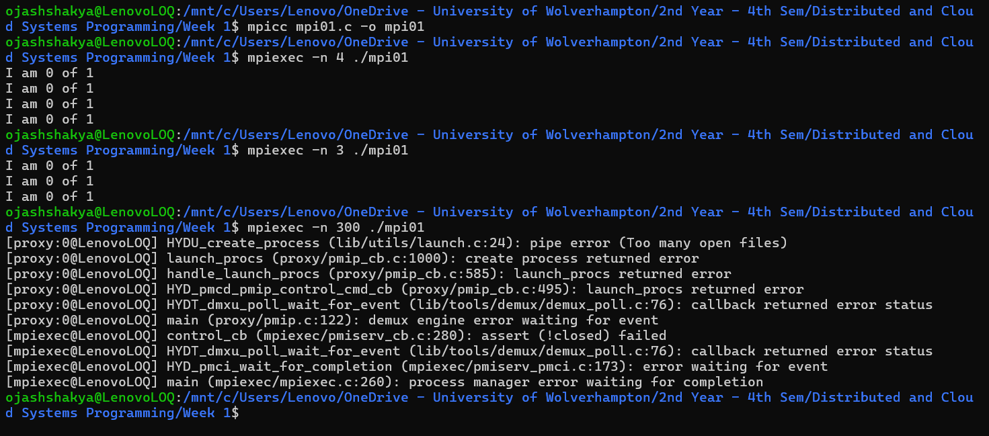

Explanation:
Here, the mpicc command compiles the program using MPI by creating an executable file mpi01. Then, mpiexec command runs the program which the first runs only on process by default and the second run uses -n to specify number for process i.e. 4 which means the program will be separated into 4 processes.

- Compile and run the program mpi02.c. Try running it with 2, 3 and 4 processes. Eg.:
mpiexec -n 2 ./mpi02
mpiexec -n 3 ./mpi02
mpiexec -n 4 ./mpi02

Note what happens. It doesn't let you run the program with anything other than 3 processes.

Output:

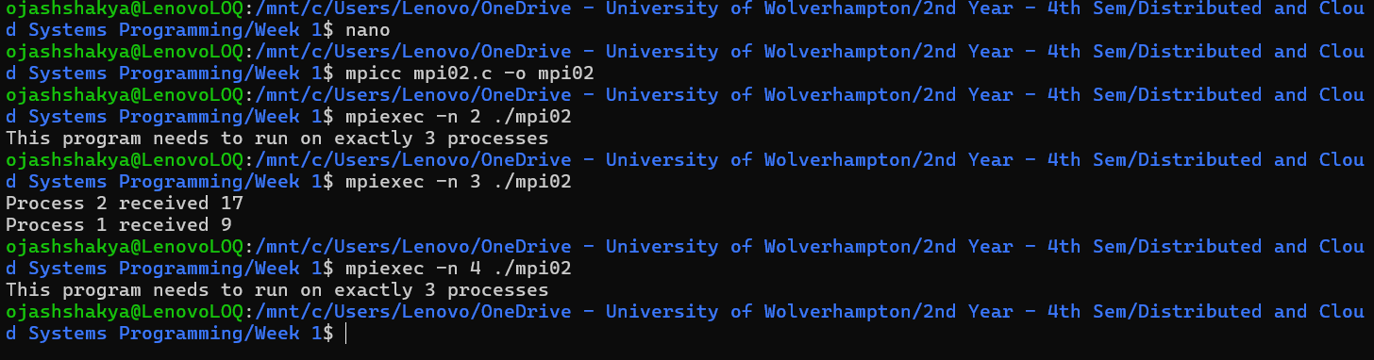

Explanation:
In this program, while running mpi02.c, it only works correctly when exactly 3 processes are used in which size refers to the number of process obtained by MPI_Comm_size(). Executing this program with 2 or 4 processes will give an error message as “This program needs to run on exactly 3 processes” as 3 processes will execute without any error.

- Now change the code so that you remove the check for only 3 processes. Now run it with 2, then 3 , then 4 and then more processes.
Program:
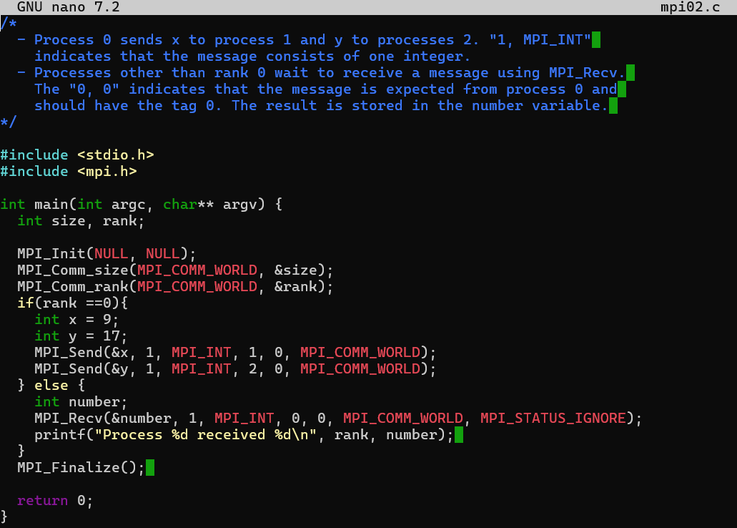
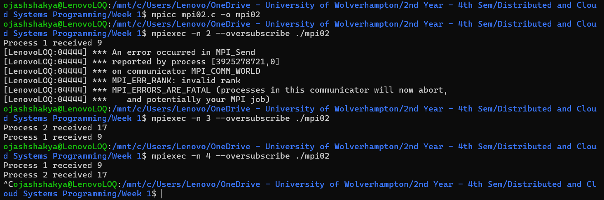
Explanation:
When the condition to check for only 3 process is removed and allowed running on any number of processes, the program can now run on any number of processes with 2, 3, 4 or more processes without errors. But, when we try to run it with 4 or more processes, the programs appear to run but never ends, we need to force end the program.

- When you try to run it with 4 or more processes, it probably runs and appears to work but never ends. You will have to end with "Ctrl-C". Why do you think it doesn't end when you run it with more than 3 processes? Change it so that it will work with any number of processes.
Program:
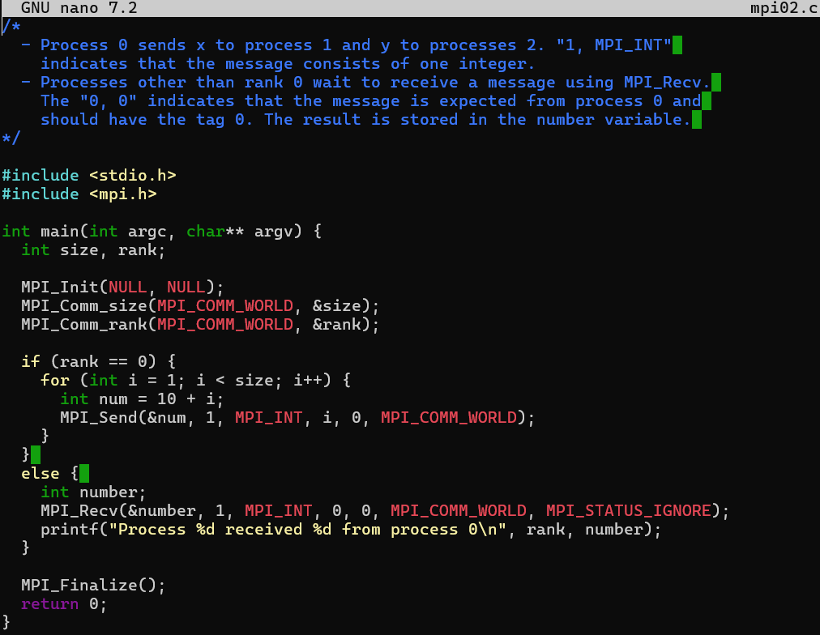
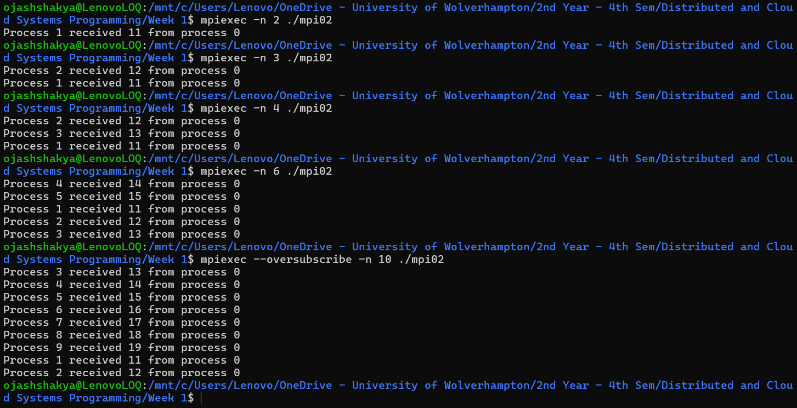

Explanation:
While running with 4 or more processes the program doesn’t stop and it hangs. It happens due to blocking communication, where the processes waiting for message from others that never get received. In MPI, if one process expects input from a specific source but never receives it, the program waits indefinitely which results in program to never end.
- Build and run the program mpi03.c. In this program Process 0 will wait for messages from Process 1 and Process 2. However, Process 1 ends up blocking Process 2 because it sleeps for 5 seconds.

Output:
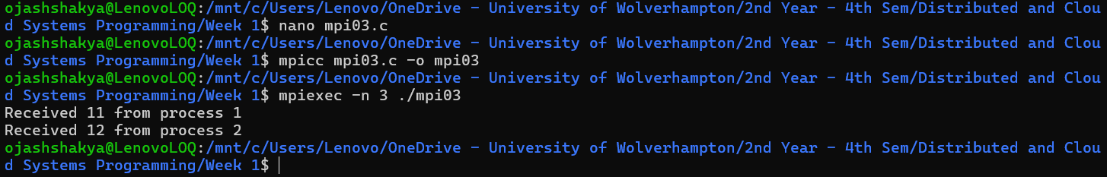

Explanation:
In this program, the process 0 waits for messages from both process 1 and process 2. However, process 1 sleeps for 5 seconds before sending its message using MPI_Send(), while process 2 sends its message immediately. As a result, Process 0 receives Process 2's message right away but remains blocked, waiting for process 1. This happens because MPI_Recv() is a synchronous, blocking function, meaning Process 0 cannot proceed until all expected messages arrive. This illustrates how delays in one process can cause others to stall, showcasing MPI's blocking behaviour.
- The following is a simple program that looks for prime numbers between 1 to 10000:

#include <stdio.h>

int main(int argc, char **argv)
{
int i, c;
int nstart=1, nfinish=10000;
printf("%s : Prime numbers between %d and %d are :\n",
argv[0], nstart, nfinish);
for(i=nstart; i<=nfinish; i++)
{
for(c=2; c<=i-1; c++)
{
if ( i%c==0 )
break;
}
if ( c==i )
printf("%s : %d\n",argv[0], i);
}
return 0;
}

Convert it to MPI so that it can run with different numbers of processes including just one process.

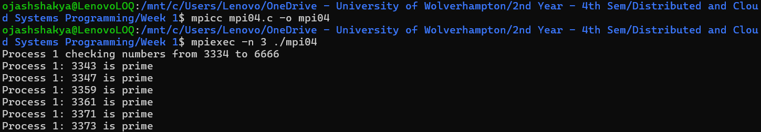
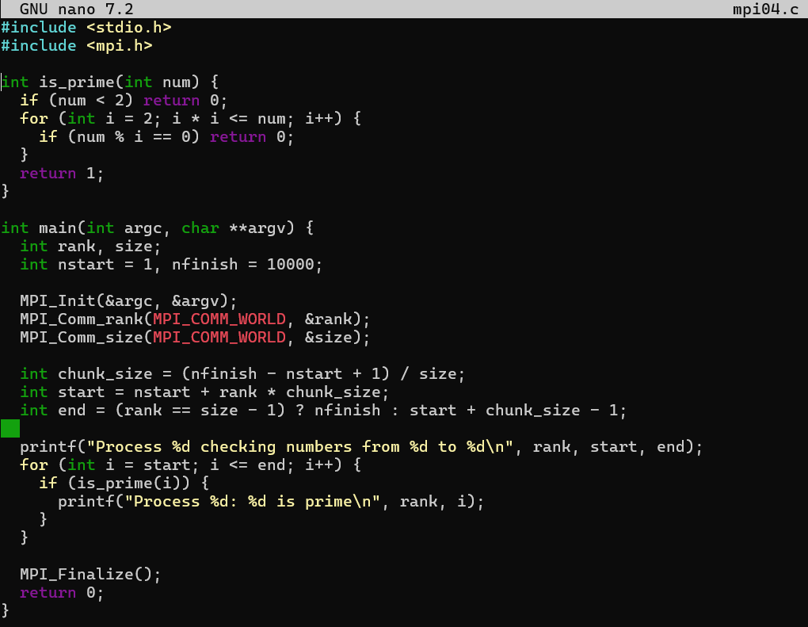
Program:

Explanation:
This program converts a sequential prime number finder into a parallel program using MPI. The original code iterates through numbers from nstart to nfinish (1 to 10,000) and checks if each number is prime by testing divisibility. To parallelize this, the range is divided among processes, so each process calculates primes within its assigned chunk. Here, size is the total number of processes, and rank is the unique ID of each process. Each process independently iterates through its range, checking for primes. The results, along with the process rank are displayed.

